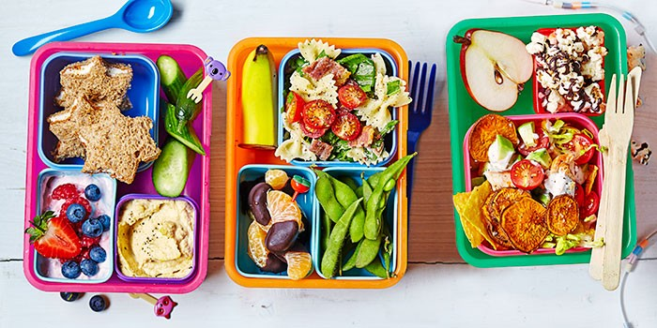

What is a healthy school?
Healthy Schools enables and supports schools to plan and implement health and well-being improvements for their children and young people.
A healthy school promotes physical and emotional health by providing accessible and relevant information and equips pupils and staff with the understanding, skills and attitudes to make informed decisions about their health. Pupils flourish in a positive environment and are given a voice to influence whole-school decisions. A healthy school understands the importance of investing in health to help pupils do their best, raise levels of achievement, improve standards and develop policies and practices to promote health.
Birthdays
Due to our healthy school status, we are unable to facilitate birthday cakes and treats on the school site. However, if your child wishes to share birthday cakes/treats they must be wrapped and handed out at the end of the school day and eaten away from the school premises.
Nut Free School
We have some children in school who suffer from food allergies including severe nut allergies, may we remind you that our school has a “No Nuts Policy”. This means that the following items cannot be bought into school:

- Packs of nuts
- Peanut butter sandwiches
- Nutella/ Chocolate Spread sandwiches
- Fruit and cereal bars that contain nuts
- Chocolate bars or sweets that contain nuts
- Sesame seed rolls (children allergic to nuts may also have a severe reaction to sesame)
- Cakes made with nuts

Please ensure that you do not send anything that says “may contain nuts.”

Snacks for Breaktime
We do allow snacks at break time but please ensure that if your child is bringing a snack it is either a piece of fruit, a small selection of vegetables (carrot sticks/cucumber) or raisins. We do not allow crisps or chocolate.
Packed Lunches
We encourage all children to bring a healthy packed lunch.
Children’s packed lunches should include items from the 5 main food groups;
1) Bread, Rice, Potatoes, Pasta. These starchy foods are a healthy source of energy. Packed lunches should include 2 or more portions eg pasta salad, sandwich.
2) Fruit and Vegetables. These foods provide vitamins, minerals and fibre. Lunches should include at least 1 portion of fruit and 1 portion of vegetables / salad, or more e.g. carrot/cucumber sticks, cherry tomatoes, a piece of fruit.
3) Milk and Dairy foods. These foods provide calcium for healthy bones and teeth. Include 1 portion at lunch e.g. yoghurt, fromage frais, milk.
4) Meat, Fish, Eggs, Beans. These foods provide protein for growth. Packed lunches should include 1 portion of these foods e.g. boiled egg as filling in sandwich, mixed bean salad.
5) Drinks – any drinks provided in lunch boxes should only include either plain water, milk (semi-skimmed), unsweetened fresh fruit juice, diluted fresh fruit juice, fruit or dairy based smoothies.

Please support us by not including these items in a packed lunch
Foods and drinks high in fat and / or sugar It is important not to fill up on too many foods that are high in fat and / or sugar at the expense of other more nutritious foods. Limiting high fat and sugar foods will help protect young people from becoming overweight as well as helping prevent tooth decay, heart disease, stroke, and diabetes.
- Fizzy Pop/Fruit shoots
- Sweets
- Chocolate bars
A choice of only one of the following is permitted in lunch boxes per day:
- A cake bar
- Packet of crisps
- Biscuit
Waste and Disposal
The school will, within reason, send any uneaten packed lunch food items back home. The rationale for this is that parents can also monitor what their child has consumed during the day and then raise any concerns over their child’s food intake with the school.

Contact

If you have any questions regarding this policy, please contact Mr Neilson via email
rneilson@nortonfree.sheffield.sch.uk.

