Week 1
Personal, social and Emotional development:Safety on bonfire night
Communication and Language: Talking about autumn starting to change to winter and what to look out for
Physical Development: Children will develop fundamental movements
Literacy:Text: Room on the broom
Writing CVC words.
Maths: Spatial Awareness
Understanding the World: Looking at the history of bonfire night
RE: Learning what a celebration is and what special celebrations our family celebrate.
Expressive arts and Design: Talking about our artist kandinsky and learning about primary colours
Music: Sing songs about animals

Phonics Ongoing phase 3

Week 3-
Personal, social and Emotional development: Talking about how we are different but similar in lots of ways too.
Communication and Language: Talking about the importance of post and delivery people at christmas time.
Physical Development: Fundamental skills, running, jumping,
Literacy: Text: The Jolly Postman
Shared stories
Maths: Composition of 4 & 5

Understanding the World: Talking about autumn and what some animals do at the end of autumn ready for winter.
RE:Talking about different festivals around the world and which ones are important to us.
Expressive arts and Design: Kandinsky : introduction of our Artist Kandinsky
Music from Charanga scheme: Listen: beyond the sea. Explore/sing: old mc Donald (add instruments)

Phonics Ongoing phase 3

FS2 Seasons and celebrations
Autumn 2 2025
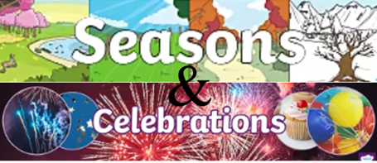
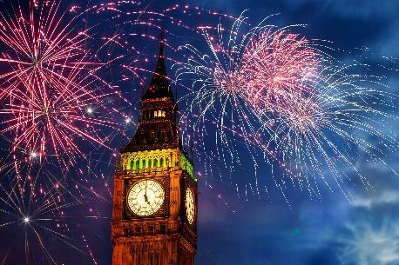
Week 2
Personal, social and Emotional development: Talking about being different and how that makes us special.
Communication and Language: Talking about diwali celebrations
Physical Development:Children will develop fundamental movements and skills such as balancing, running, jumping, travelling, and changing direction.
Literacy:Text:Room on the broom sentences I put a …. in the pot.
Maths: Subitizing 4 & 5
Understanding the World: Learning about autumn and the weather changing to colder/ darker etc
RE: All about the Diwali festival of light
Expressive arts and Design: Learning that all secondary colours can be made by mixing the three primary colours.
Rangoli rice Art

Music from Charanga scheme – Singing

Phonics Ongoing phase 3

Week 5
Personal, social and Emotional development:Discussing ways that we can be a kind friend.
Communication and Language: Talking about celebrations that are happening soon.
Physical Development:Learning to move to music from the nativity play
Literacy: Text: The stickman
Drawing a story map of the stickman
Maths: 2D shape
Understanding the World: Talking about season change. Talking about how the season is changing from autumn to winter. Looking for signs of winter.
RE: Talking about how christians prepare for advent and how typical traditions of christmas.
Expressive arts and Design: Kandinsky wool felting circles
Music Charanga Listen: Frogs legs and Dragon teeth. Explore/sing: Incy Wincy (add instruments).
Phonics ongoing phase 3

Week 7
Personal, social and Emotional development: Talking about special events with family.
Communication and Language: Talking about christmas celebrations
Physical Development:Christmas inspired games
Literacy:Text: Dear santa
(assessment week)
Maths: Assessment week
Understanding the World: presents in the past compared to presents today ( in the present)
RE: Learning the reason behind giving gifts at christmas time.
Expressive arts and Design: Christmas inspired Art work.
Music from Charanga scheme – Singing

Phonics Ongoing phase 3
Week 4
Personal, social and Emotional development:Talking about why my home is special to me
Communication and Language: Talking about animals that hibernate in winter and nocturnal animals.
Physical Development:Children will develop fundamental movements and skills such as balancing, running, jumping, travelling, and changing direction.
Literacy: Text: The Jolly Postman
Shared stories
Maths:one more one less

Understanding the World: Talking about animals that hibernate and nocturnal animals

RE: continue learning about different festivals that are important to different religions and comparing them to festivals the children celebrate at hone.
Expressive arts and Design: Kandinsky circles : Wool felting

Music Charanga scheme

Phonics ongoing phase 3

Week 6
Personal, social and Emotional development: knowing how to stand up for yourself. What to say if you don't like something someone id saying/doing.
Communication and Language: Learning parts and roleplaying parts in the nativity play
Physical Development: Christmas inspired games
Literacy:Text: The Stickman
Labelling story maps of the stickman
Maths: night and day / Assessment week
Understanding the World: Talking about the christmas story

RE:Learning what special things christians do at christmas time to share god’s love.
Expressive arts and Design: Kandinsky art: oil/chalk circle pictures. Blending primary colours to make secondary ones.
Music: Charanga scheme
Phonics ongoing phase 3



