Science – Rocks
Types of Rocks
Compare different kinds of rocks based on their
appearance in the context of understanding the difference between natural and human-made rocks.

Grouping Rocks
Making systematic and careful observations by examining different types of rocks.

Fantastic Fossils
Describe in simple terms how fossils are formed when things that have lived are trapped within rock by explaining the fossilisation process and by comparing fossils to the animals they belong to.

Mary Anning
Identifying changes related to simple scientific ideas in the context of theories about fossils.

Soil Formation
Recognise that soils are made from rocks and organic matter by explaining how soil is formed.

Soil Profiles
Making systematic and careful observations in the context of investigating the permeability of different soils.

Geography
Extreme Earth:
- In Geography, we will be learning about the destructive powers of nature, from volcanoes and earthquakes to tsunamis and tornadoes. We will be learning how these natural phenomena occur, and the ways in which they affect people and the environment.
- Key words: Earth, layers, tectonic plates, core, rock, earthquake, tsunami, volcano, tornado.

Year 3 Knowledge Organiser
Autumn 2
Let’s Rock

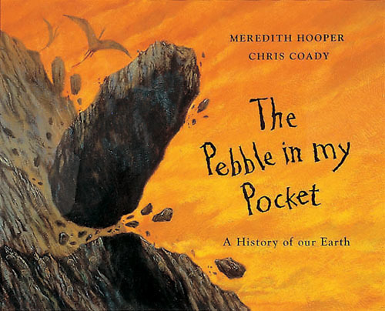

Art and Design
Colour:
- Learning about warm and cool colours and the colour wheel.
- Practising mixing colours.
- Key words: Colour, tone, warm, cool, opposite, primary, dark, light.

Our author this half term is:
Meredith Hooper

R.E.
Beliefs and Questions:
- Understanding the commitments and challenges of being a Christian.
- The Christian Christmas story and the link to traditional carols.
- Key words: Christianity, commitment, prayer, worship, challenge, temptation, Jesus, holy.

Reading
Every morning, the children will complete their reciprocal reading activity. These texts will be based on Fantastic Earth Facts by Miles Kelly. Each Friday, we will work on our comprehension skills using a variety of fiction and non-fiction texts and question styles.
Home Learning
Each week, five spelling activity mats will be sent home as part of the Year 3 homework. These will tie into our weekly spelling test of Y3/4 statutory words.

Maths
Addition & Subtraction
Week 1:
Add two 2-digit numbers - crossing 10 - add ones & add tens,
subtract a 2-digit number from a 2-digit number - crossing 10 and assessment.
Multiplication & Division
Week 2:
Multiplication and equal groups – using arrays – 2 times and 5 times tables.

Week 3:
Sharing and Grouping – divide by 2 – divide by 5 – divide by 10.

Week 4:
Multiply by 3 – divide by 3 – the 3 times table

Week 5:
Multiply by 4 – divide by 4 – the 4 times table

Week 6:
Multiply by 8 – divide by 8 – the 8 times table

Plus:
Seasonal activities and fun math games

English
Book: The Pebble in My Pocket by Meredith Hooper
Each day we will read a few pages of the story.
Week 1 | Week 2 | Week 3 | Week 4
Explanation text: Layers of the Earth. Using paragraphs and subtitles. | Whole School Writing Week: Special object in a matchbox. | Recount:  Exploring the language of recount texts. | Recount: Making Christmas slime.  Writing a recount using time adverbials.
Spelling and Grammar:
Accurate use of the determiners a or an | Accurate use of the determiners a or an | Expressing time and place using adverbs then, next, soon, so | Expressing time and place using adverbs then, next, soon, so

Week 5 | Week 6
Play script, including stage directions. Drama: T’was the Night Before Christmas | Performance poetry/play: T’was the Night Before Christmas. Drama.  Christmas activities.
Spelling and Grammar:
Key words:  Consonant  Vowel | Key words:  Consonant  Vowel | Recap

