History - Ancient Egypt:
- In history, we will be discovering about the Ancient Egyptians and how they lived:
  - The difference between AD and BC.
  - When the Ancient Egyptian civilisation took place.
  - Where Egypt is located and features of modern Egypt.
  - Clues and artefacts left behind that show us how Ancient Egyptians lived.
  - All about Tutankhamun.
  - Life after death in Ancient Egypt.
- Key words: Egypt, pyramid, pharaoh, civilisation, ancient, modern, artefacts, Nile, landscape, Tutankhamun, tomb, mummification, mummies, sarcophagi

Science – Skeletons
Lesson 1: Types of Nutrition Identify that they cannot make their own food; they get nutrition from what they eat by comparing how plants and humans obtain food.
Lesson 2: Types of Skeleton Identify that humans and some other animals have skeletons by investigating skeleton types
Lesson 3: Naming Bones Identify that humans and some other animals have skeletons by identifying the parts of the skeleton.
Lesson 4: Functions of a Skeleton Identify that humans and some other animals have skeletons for support, protection and movement, by focusing on skeleton types.
Lesson 5: Mighty Muscles Identify that humans and some other animals have muscles for movement by examining how muscles work. I know why we need muscles to move.
Year 3 Knowledge Organiser
Spring 1
Digging It
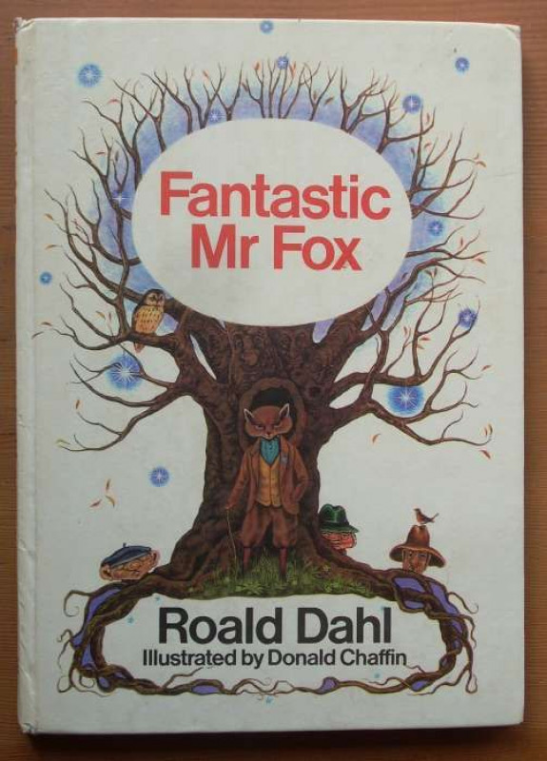

Art and Design
Sketching, Designing and Sculpting:
- Appraising and discussing art.
- Sketching and designing on a theme.
- Sculpting using clay.
- Key words: Sculpt, mould, smooth, texture, tools, slip, evaluate, appraise.

R.E. - Life and Death:
- Understanding that life can be seen as a journey.
- Knowing that Christians see scripture as a guide to life.
- Thinking about what gives life meaning.
- Understanding the concept of living.
- Discussing Christian thoughts on heaven and resurrection.
- Key words: Christianity, life, death, resurrection, heaven, Good Samaritan, scripture, journey

Our author this half term is:
Roald Dahl

Home Learning
Each week, five spelling activity mats will be sent home as part of the Year 3 homework. These will tie into our weekly spelling test of Y3/4 statutory words.

Reading
Every morning, the children will complete their reciprocal reading activity.
Each Friday, we will work on our comprehension skills using a variety of fiction and non-fiction texts and question styles.

Maths
Our times table focus this term is the 4 x tables. Try to practise your 4 times tables at home. These are your foundation blocks for maths knowledge.

Week 1 | Week 2 | Week 3
Multiplication –  Multiply 2 digits by 1 digit | Multiplication –  Multiply 2 digits by 1 digit | Division – Divide 2 digits by 1 digit  Divide with remainders  Assessment

Week 4 | Week 5 | Week 6
Length –  Metres  Centimetres  Millimetres  Compare length  Add length | .  Perimeter –  What is perimeter?  Measure perimeter?  Add perimeter? | Consolidation –  Measure length CM  Measure length M  Measure length MM  Assessment

English
Book: Fantastic Mr Fox by Roald Dahl
Each day we will read a few pages of the story.
Week 1 | Week 2 | Week 3 | Week 4
(3 day week)  SPAG and comprehension:  Word families. | Fiction: Talk 4 Writing Week 1  Little Vixen Street | Fiction: Talk 4 Writing Week 2  Little Vixen Street | Fiction: Talk 4 Writing Week 3  Little Vixen Street
Spelling and Grammar:
Word families based on common words – Prefixes dis-, un- and re-. | Recap of SPAG so far | Expressing time and place using prepositions before, after, during, in, because of | Introduction to speech marks to punctuate direct speech

Week 5 | Week 6
Persuasion: Egypt brochure week 1 | Persuasion:  Egypt brochure week 2
Spelling and Grammar:
Recap of SPAG so far | Word families based on common words - Suffixes

