Science – Forces & Magnets
Lesson 1: To notice that some forces need contact between two objects by identifying the different types of forces acting on objects
Lesson 2: To compare how things move on different surfaces by investigating the speed of a toy car over different surfaces
Lesson 3: To notice that magnetic forces can act at a distance and attract some materials and not others by sorting materials
Lesson 4: To observe how magnets attract or repel each other and attract some materials and not others by investigating the strength of different magnets. I can investigate the strength of magnets
Lesson 5: To describe magnets as having two poles and to predict whether two magnets will attract or repel each other
Lesson 6: To observe how magnets attract or repel each other and attract some materials and not others
Geography – The Nile:
- In geography, we will be exploring the river Nile and
  - Describing the location and features of the Nile.
  - Describing the journey of the river from source to mouth.
  - Learning about the Aswan High Dam and the positive and negative effects on the river.
  - The physical and human geography of the Nile delta.
  - How uses for the Nile have changed over time.

- Key words: Egypt, Nile, source, mouth, floodplain, delta, Aswan High Dam.

Year 3 Knowledge Organiser
Spring 2 2023
Walk Like an Egyptian
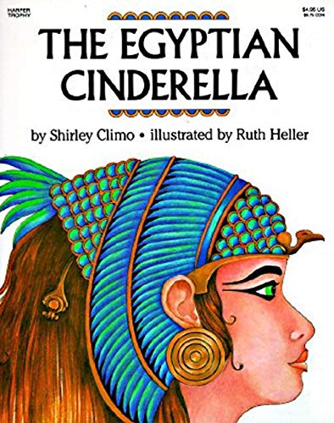

Art and Design: Watercolour
- Appraising and discussing art.
- Learning watercolour techniques.
- Designing a wax resist watercolour Egyptian cartouche
- Key words: Wash, blend, wet, dry, strength of colour, evaluate, appraise.

R.E. - Life and Death: Islam
- Understanding Christianity – 10 minute starter each lesson.
- Learning about the 5 pillars of Islam.
- Exploring Muslim birth ceremonies and naming days.
- Finding out about Muslim marriage ceremonies.
- Knowing about Muslim funeral ceremonies.
- Understanding the importance of the Hajj for Muslim people.
- Comparing and contrasting Islam and Christianity.
- Key words: Christianity, Islam, Muslim, the five pillars, Hajj, Allah, prayer.

Our author this half term is:
Shirley Climo

Reading
Every morning, the children will complete their reciprocal reading activity.
Each Friday, we will work on our comprehension skills using a variety of fiction and non-fiction texts and question styles.
Home Learning
Each week, five spelling activity mats will be sent home as part of the Year 3 homework. These will tie into our weekly spelling test of Y3/4 statutory words.

Maths
Our times table focus this term is the 4 x tables. Try to practise your 4 times tables at home. These are your foundation blocks for maths knowledge.

Week 1 | Week 2 | Week 3
Fractions –  Make equal parts  Recognise a half  Find a half  Recognise a quarter  Find a quarter  Recognise a third | Fractions –  Unit fractions  Non-unit fractions  Unit and non-unit fractions  Equivalent fractions  Use a fraction wall  Assessment | Mass and Capacity –  Use scales  Measure mass in grams and kilograms  Equivalent masses  Compare mass  Add and subtract mass

Week 4 | Week 5 | Week 6
Mass and Capacity –  Measure capacity in millilitres  Measure capacity in litres  Equivalent capacities  Compare capacity  Add and subtract capacity | .  Practical maths week –  Mass and capacity  Practical fraction games  Numicon activities | Arithmetic Week-  Add with exchange  Subtract with exchange  Multiplication  Division

English
Book: The Egyptian Cinderella by Shirley Climo.
We will also be reading Lottie Lipman and the Curse of the Cairo Cat by Dan Metcalf during our story session at the end of each day.
Week 1 | Week 2 | Week 3 | Week 4
Review: Exploring the features of a book review, planning and writing our own. | Persuasion: Planning and writing a persuasive piece; “Three Reasons Why You Should…” | Fiction: Tales of Ancient Egypt. The Egyptian Cinderella.  Talk for Writing based unit. | Fiction: Tales of Ancient Egypt. The Egyptian Cinderella.  Talk for Writing based unit.
Spelling and Grammar:
Recapping adjectives and descriptive techniques, i.e., similes.  Words ending le. | Headings and subheadings to aid presentation.  Introduction to paragraphs as a way to group related material. | Recapping word classes. Focus on capital letters and punctuation.  Double letters before other endings. Words ending el, al and il. | Fronted adverbials.  Recapping conjunctions and adverbs.  Speech marks to punctuate direct speech.

Week 5 | Week 6
Non-chronological report: Ordering and sorting statements. Using subheadings. | Non-chronological report: Planning and writing a non-chronological report about Egypt.
Spelling and Grammar:
Introduction to paragraphs as a way to group related material.  Headings and subheadings to aid presentation. | Introduction to paragraphs as a way to group related material.  Headings and subheadings to aid presentation.

