History - Ancient Egypt:
- In history, we will be discovering about the Ancient Egyptians and how they lived:
  - The difference between AD and BC.
  - When the Ancient Egyptian civilisation took place.
  - Where Egypt is located and features of modern Egypt.
  - Clues and artefacts left behind that show us how Ancient Egyptians lived.
  - All about Tutankhamun.
  - Life after death in Ancient Egypt.
- Key words: Egypt, pyramid, pharaoh, civilisation, ancient, modern, artefacts, Nile, landscape, Tutankhamun, tomb, mummification, mummies, sarcophagi

Science – Skeletons
Lesson 1: Types of Nutrition Identify that they cannot make their own food; they get nutrition from what they eat by comparing how plants and humans obtain food.
Lesson 2: Types of Skeleton Identify that humans and some other animals have skeletons by investigating skeleton types
Lesson 3: Naming Bones Identify that humans and some other animals have skeletons by identifying the parts of the skeleton.
Lesson 4: Functions of a Skeleton Identify that humans and some other animals have skeletons for support, protection and movement, by focusing on skeleton types.
Lesson 5: Mighty Muscles Identify that humans and some other animals have muscles for movement by examining how muscles work. I know why we need muscles to move.
Year 3 Knowledge Organiser
Spring 1 2024
Digging It
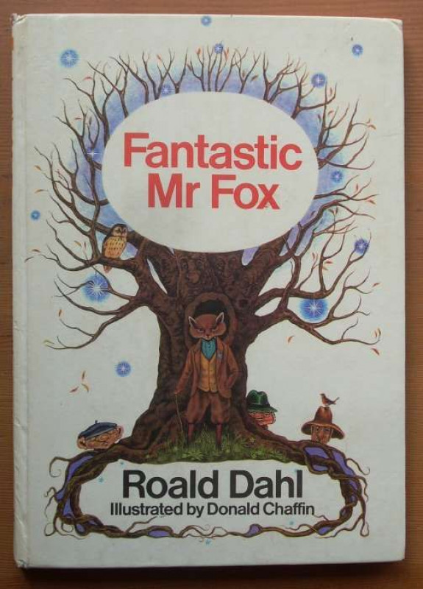

Art and Design
Sketching, Designing and Sculpting:
- Appraising and discussing art.
- Sketching and designing on a theme.
- Sculpting using clay.
- Key words: Sculpt, mould, smooth, texture, tools, slip, evaluate, appraise.

R.E. - Life and Death:
- Understanding that life can be seen as a journey.
- Knowing that Christians see scripture as a guide to life.
- Thinking about what gives life meaning.
- Understanding the concept of living.
- Discussing Christian thoughts on heaven and resurrection.
- Key words: Christianity, life, death, resurrection, heaven, Good Samaritan, scripture, journey

Our author this half term is:
Roald Dahl

Home Learning
Each week, the children will receive a number of statutory Y3 spellings to learn. Please continue to read at home.

Reading
Every morning, the children will complete their reciprocal reading activity.
Each Friday, we will work on our comprehension skills using a variety of fiction and non-fiction texts and question styles.

P.E.
Mondays – Dance until February, then swimming.
Fridays - Coach Nathan – Athletics.

Maths
Our times table focus this term is the 4 x tables. Try to practise your 4 times tables at home. These are your foundation blocks for maths knowledge.

Week 1 | Week 2 | Week 3
Multiplication –  Multiply 2 digits by 1 digit | Multiplication –  Multiply 2 digits by 1 digit | Division – Divide 2 digits by 1 digit  Divide with remainders  Assessment

Week 4 | Week 5 | Week 6
Length –  Metres  Centimetres  Millimetres  Compare length  Add length | .  Perimeter –  What is perimeter?  Measure perimeter?  Add perimeter? | Consolidation –  Measure length CM  Measure length M  Measure length MM  Assessment

English
Book: Fantastic Mr Fox by Roald Dahl
Each day we will read a few pages of the story.
Week 1 | Week 2 | Week 3 | Week 4
Fiction: Talk 4 Writing Week 1  Little Vixen Street | Fiction: Talk 4 Writing Week 2  Little Vixen Street | Fiction: Talk 4 Writing Week 3  Little Vixen Street | Persuasion: Egypt brochure week 1
Spelling and Grammar:
Word families based on common words – Prefixes dis-, un- and re-. | Recap of SPAG so far | Expressing time and place using prepositions before, after, during, in, because of | Introduction to speech marks to punctuate direct speech

Week 5 | Week 6
Persuasion: Egypt brochure week 2 | N/A
Spelling and Grammar:
Recap of SPAG so far | N/A

