Geography and History – Vikings:
- In geography and history, we will be exploring the Vikings and their wild warrior ways.
  - Locating and labelling the British Isles and the Nordic regions on a map of Europe.
  - Know the paths taken by invading Vikings.
  - Understand why Vikings settled in Britain.
  - To think about the daily lives of Vikings; Clothes, food and drink and roles within the village.
  - To know how ancient artefacts can help us uncover how people lived in the past.
- Key words: Vikings, Anglo-Saxons, Celts, British Isles, Scandinavia, invasion, Lindisfarne, Gods, Goddesses, settlement

Science –
1. Parts of Plants: To identify and describe the functions of different parts of flowering plants: roots, stem/trunk, leaves and flowers
2. What Do Plants Need to Grow Well? To explore the requirements of plants for life and growth (air, light, water, nutrients from soil, and room to grow)
3. What Have You Found Out? To record findings using simple scientific language, drawings, labelled diagrams, keys, bar charts and tables
4. Moving Water: To investigate the way in which water is transported within plants
5. Fantastic Flowers: To explore the part that flowers play in the life cycle of flowering plants, including pollination, seed formation and seed dispersal
6. Life Cycle: To explore the part that flowers play in the life cycle of flowering plants, including pollination, seed formation and seed dispersal
Year 3 Knowledge Organiser
Summer 1 2024
Striking Vikings
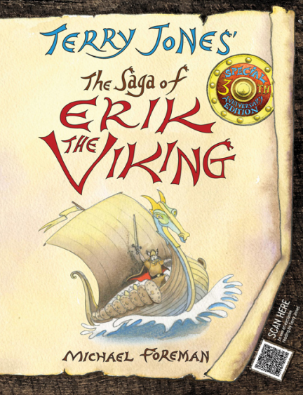

Art and Design: Viking Art
- Sketching skills; Light and shade
- Drawing knots and patterns
- Key words: Knot, pattern, weave, Oseberg, Borre, Jellinge, Mammen, Ringerike and Urnes

R.E. – Jewish Beliefs and Celebrations
- Learning about the Jewish holy book.
- Thinking about how the Israelites escaped Egypt.
- Understanding Purim as a festival.
- Knowing about the celebrations of Rosh Hashanah, Sukkot and Hanukkah.
- Key words: Torah, Judaism, Moses, Purim, Rosh Hashanah, Hanukkah, Sukkot, Israelites.

Our author this half term is:
Terry Jones

Reading
Every morning, the children will complete their reciprocal reading activity.
Each Friday, we will work on our comprehension skills using a variety of fiction and non-fiction texts and question styles.
Home Learning
We will begin our summer reading focus. Each week, the children will bring home a different text with comprehension questions to accompany it, helping us to practise our retrieval, inference, predicting and summarising skills.

Maths
Our times table focus this term is the 4 x tables. Try to practise your 4 times tables at home. These are your foundation blocks for maths knowledge.

Week 1 | Week 2 | Week 3
FRACTIONS  Add fractions  Subtract fractions  Partition the whole  Unit fractions  Non-unit fractions  Assessment | MONEY  Pounds and Pence  Convert £ and pence  Add money | MONEY Cont…  Subtract money  Find change  Assessment  TIME  Roman number to 12

Week 4 | Week 5 | Week 6
Tell the Time to 5 min  Tell the time to 1 min  Read a digital clock  Use am and pm  Years, months, days | Days and hours  Hours & minutes  Hours & minutes Pt2  Minutes and seconds  Units of time | Time problems  Time problems Pt2  Assessment

English
Book: The Saga of Erik the Viking by Terry Jones

Week 1 | Week 2 | Week 3 | Week 4
Recount: Exploring our local area: Walk around Norton, noting buildings of significance and different housing. | Explanation: Viking Settlements compared to modern Norton: | Fiction: Viking Sagas.  Nouns and descriptive noun phrases. Using first person in creative writing. | Fiction: Viking Sagas.  Descriptive noun phrases and inverted commas
Spelling and Grammar:
Time conjunctions. Adverbs. | Paragraphs as a way to group related material. | Paragraphs as a way to group related material.  Classifying nouns. | Speech marks to punctuate direct speech.

Week 5 | Week 6
Poetry: Viking Poem – The Godless  Performance poetry with actions. | Poetry:  Innovating our own version of The Godless
Spelling and Grammar:
Using inverted commas | Use of the perfect form of verbs to mark relationships of time and cause

