History and Geography
The Tudor Dynasty and
- Place knowledge: Understanding geographical similarities and differences.
- Physical geography: Weather and the equator
- Distribution of natural resources, including food. Comparing past and present.
- Looking at people of historical interest, including Tudor monarchs and explorers (Henry VIII, Elizabeth I, Francis Drake)
- Exploring the six wives of Henry VIII and the break with Rome.
- Learning about the Spanish Armada.
- Asking valid historical questions and examining historical sources.
- Key words: Caribbean, export, galleon, Tudor, dynasty, monarch, Rome, exploration, sources, armada

Science Light and Dark
To recognise that we need light in order to see things and that dark is the absence of light.
To notice that light is reflected from surfaces by choosing the most reflective material for a new book bag. To notice that light is reflected from surfaces by playing mirror games.
To recognise that light from the sun can be dangerous and that there are ways to protect our eyes.
To recognise that shadows are formed when the light from a light source is blocked by a solid object
To find patterns in the way that the sizes of shadows change by investigating what happens when you change the distance between the object and the light source.
Create a puppet theatre using knowledge from this topic.
Key Words: beam, transparent, translucent, opaque, absence, reflection, shadow, convex, concave

Year 3 Knowledge Organiser
Autumn 1 2025
Our authors this half term are Philip Reeve and Sarah McIntyre and our class book is Oliver and the Seawigs.
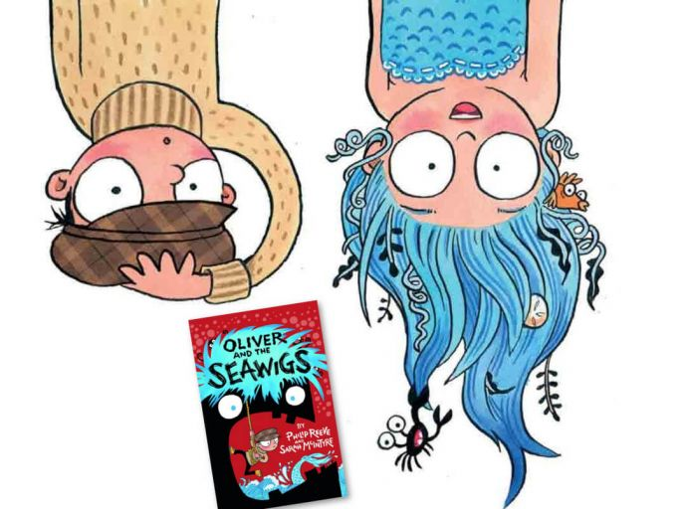

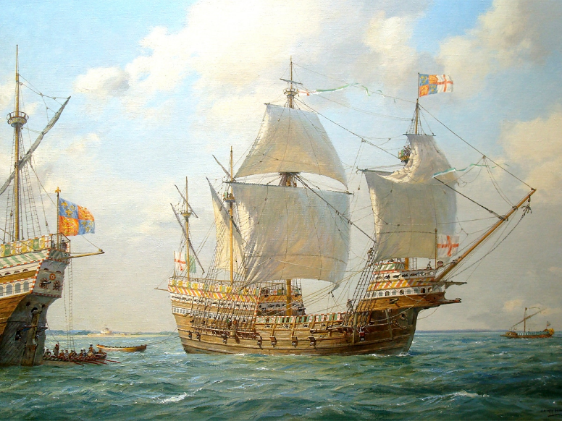

Sailing through Time
R.E.
Beliefs and Questions:
- The Christian creation story; God made the world in 7 days.
- Adam and Eve, the garden of Eden and the first sin.
- Humanist creation beliefs; The origin of the Universe and human life.
- How Christian people worship God as the creator.
- Looking at scripture around creation.
- Thinking about our own beliefs.
- Key words: Christianity, creation, saviour, creator, universe, humanism, cosmologists, evolution

Art and Design
Sketching and Shading:
- Learning different techniques to improve our drawing skills.
- Key words: Sketching, shading, cross-hatching, texture, line, tone, figure, perspective, light, shadow

Reading
Every morning, the children will complete their reciprocal reading activity.
Each Friday, we will work on our comprehension skills using a variety of fiction and non-fiction texts and question styles.

Maths
Place Value
Week 1:
Represent numbers to 100, tens and ones using addition and hundreds and represent numbers to 1,000.
Week 2:
100s, 10s and 1s (1), 100s, 10s and 1s (2), number line to 1,000
and find 1, 10, 100 more or less than a given number.
Week 3:
Compare objects to 1,000, compare numbers to 1,000, order numbers, count in 50s and assessment.
Addition and Subtraction
Week 4:
Add and subtract multiples of 100, add and subtract 1s and
add and subtract 3-digit and 1-digit numbers – not crossing 10.
Week 5:
Add a 2-digit and 1-digit number - crossing 10, add 3-digit and 1-digit numbers – crossing 10 and subtract a 1-digit number from 2-digits - crossing 10.
Week 6:
Subtract a 1-digit number from a 3-digit number – crossing 10,
add and subtract 3-digit and 2-digit numbers – not crossing 100
and add 3-digit and 2-digit numbers – crossing 100.
Week 7:
Subtract a 2-digit number from a 3-digit number – crossing 100,
add and subtract 100s and spot the pattern – making it explicit.
Week 8:
Add two 2-digit numbers - crossing 10 - add ones & add tens,
subtract a 2-digit number from a 2-digit number - crossing 10 and assessment.

English
Reciprocal Reading: Oliver and the Seawigs by Philip Reeve and Sarah McIntyre
Each day we will read a few pages of the story, with our English work linked to the exciting adventures happening within the pages.
Week 1 | Week 2 | Week 3 | Week 4
Oliver and the Seawigs  Character work and capital letters. | Oliver and the Seawigs  Description and expanded noun phrases. | All About the Albatross  Non-fiction writing | All About the Albatross  Non-chronological  report writing

Week 5 | Week 6 | Week 7
Flotsam  Past tense and adverbs | Flotsam  Descriptive narrative | Nen and the Lonely Fisherman  Inference and fictional narrative

Each Monday, the children will begin learning their new spellings and will continue working on these throughout the week.
Spelling homework will go home each Monday, to be tested the following Monday.

