Geography and History – Mountains and the Ice Age.
- In geography and history, we will be learning about mountain ranges, rivers and the Ice Age, including the people and living creatures who existed during the era.
  - Locating and labelling mountain ranges around the world.
  - Know the physical features of a mountain and valley.
  - Know and name the features of a river and know some local rivers.
  - To understand what makes an Ice Age.
  - To know and understand what life and survival would have been like for Homosapiens, Neanderthals and the megafauna during this time.
- Key words: Mountain, range, river, Ice Age, glacier, land bridge, Homosapien, Neanderthal, megafauna, survival, extinction.

Year 3 Knowledge Organiser
Summer 2
Science – Scientists & Inventors
1. Marie Curie - To identify changes related to scientific ideas by describing Marie Curie’s research into x-rays and explain how her work helps us to identify bones.
2. George Washington Carver - To identify changes related to scientific ideas by describing the achievements of George Washington Carver.
3. William Smith – We can find out the age of rocks by identifying the organisms that have been trapped inside them.
4. Inge Lehmann – To find out how this pioneering, female scientist discovered that the Earth’s core was solid and not liquid.
5. Concave and Convex - To notice that light is reflected from surfaces by investigating concave and convex mirrors. To ask relevant questions.
6. Where in the World? - To identify changes related to scientific ideas by finding out about inventions from all over the world.

Frozen in Time
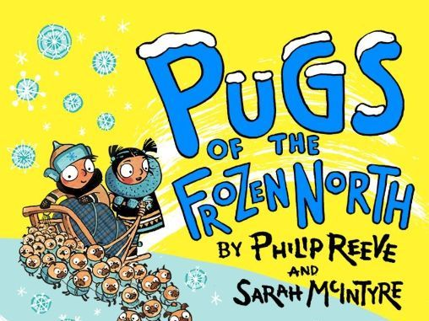

Art and Design: Collage
- Collage skills; Landscapes
- Revisiting warm and cool tones and perspective.
- Key words: Landscape, depth, perspective, tones, layers.

Our class book and authors this half term:
Pugs of the Frozen North by Philip Reeve and Sarah McIntyre

R.E. – Christianity and Hinduism
- We will be beginning each RE session with our Understanding Christianity lesson starters.
- Thinking about the Hindu Gods and Goddesses and why they are important to Hindu people.
- Knowing about the importance of the mandir and home shrines of Hindu families.
- Key words: Hinduism, aum symbol, Brahman, arti (ghee butter lamp), shrine, mandir.

Reading
Every morning, the children will complete their reciprocal reading activity.
Each Friday, we will work on our comprehension skills using a variety of fiction and non-fiction texts and question styles.
Home Learning
We will begin our summer reading focus. Each week, the children will bring home a different text with comprehension questions to accompany it, helping us to practise our retrieval, inference, predicting and summarising skills.

Maths
Our times table focus this term is the 8 x tables. Try to practise your 8 times tables at home. These are your foundation blocks for maths knowledge.

Week 1 | Week 2 | Week 3
Time:  Units of time  Comparing time  Consolidation and assessment | 2D and 3D:  Turns and angles  Right angles  Compare angles  Measure and draw accurately | 2D and 3D:  Horizontal and vertical  Parallel and perpendicular  Recognise and describe 2-D shapes  Recognise and describe 3-D shapes  Make 3-D shapes  Draw polygons  Assessment

Week 4 | Week 5 | Week 6
Statistics:  Interpret Pictograms  Draw Pictograms  Interpret Bar Charts  Draw Bar Charts | Statistics:  Collect Data  Represent Data  Two Way Tables  Assessment | CONSOLIDATION

English
Book: Pugs of the Frozen North by Philip Reeve and Sarah McIntyre

Week 1 | Week 2 | Week 3 | Week 4
SPAG focus: Perfect verbs | Explanation text: What is ice?  WAGOLL: What are clouds?  Word level, sentence level, text level. | *School trip*  Non-chronological report – The Ice Age. | Recount – School trip  Retelling, with a focus on personal experience – Using the first person.
Spelling and Grammar:
Perfect past tense verbs, perfect present verbs, perfect future tense verbs. | Adjectives  Grouping information using paragraphs.  Using titles and subtitles. | Adjectives  Grouping information using paragraphs.  Using titles and subtitles. | Use of time conjunctions.  Use of the perfect past tense.

Week 5 | Week 6
Recount – Our year  Retelling, with a focus on personal favourites – Using the first person. | English activities and games
Spelling and Grammar:
Use of time conjunctions.  Use of the perfect past tense. | English activities and games

FRENCH
Recapping previous vocabulary – colours, numbers, animals
PE: Monday – Swimming + Thursday – Team Games

