

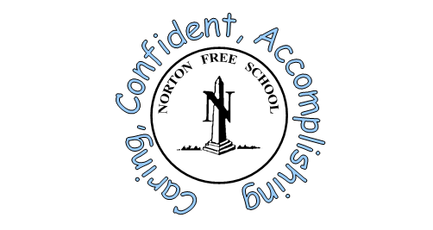



Norton Free Church of England
Primary School
A Guide to our Breakfast Club
2025-2026

Our Vision Statement:
‘Our school is a caring, Christian Community, with Jesus Christ at the heart of everything we do. It provides a safe, nurturing environment enabling all children to flourish, to be the best they can be, to value themselves and others and to live joyfully and in peace'



Norton Free C of E Primary School Breakfast Club
- Norton Free C of E School operates a Breakfast Club on Monday, Tuesday, Wednesday, Thursday and Friday mornings during term time only.
- Our Breakfast Club is Ofsted Registered - the registration number is 107106.
- Two member of staff are present at Breakfast Club – Mrs Rasdale (M-F) and Mrs Hall (M-F). Mrs Rasdale holds a paediatric first aid qualification. Miss Gelder will also be present if numbers are high.
- Breakfast club starts at 07:45am, please try not to arrive before this time as staff will be setting up and preparing the dining hall.
- We offer a healthy breakfast consisiting of a choice of cereal, toast, yoghurt or fresh fruit with a drink of water, juice or milk to drink.
- You will need to register your child for breakfast club by emailing/giving the registration form available in this booklet (or on the website) to the head teacher or the school office (3rd page in this booklet) and then book your preferred days.
- Please book the days you require by indicating on the form (page 4), the days you will use. Please provide your child’s details and a note about anything you feel we need to know. This will enable us to keep a track of pupil numbers. You will not be charged if you don’t use the breakfast club.
- You may arrive between 07:45am and 08:20am (please note that breakfast will not be available after 08:20am)
- The cost for breakfast club is £4.00 per session – per child.
- Childcare vouchers accepted
- Contact Mrs Lee in the school office for more details.



Norton Free C of E Primary School - Breakfast Club Child/ren Registration:
Contract agreement/Registration Form (Part A)
Parent Name (1) _________________________ Parent Name (2)____________________________

Contact Number (1) Contact Number (2)

Child 1 - Legal Name:____________________________ Date of Birth: ___________________________
Child’s preferred Name: ____________________________
Child 2 – Legal Name:________________________________ Date of Birth: ___________________________
Child’s preferred Name: ____________________________
Child 3 – Legal Name:________________________________ Date of Birth: ___________________________
Child’s preferred Name: ____________________________
Address:

Postcode:
Additional Information e.g dietary restrictions/requirements, likes/dislikes or other health matters:

Please return this form to the school office.

Emergency Contact number if different from the above information:
Name: Telephone number:
Address: Mobile number:

Relationship to child:

I

Norton Free C of E Primary School Breakfast Club Booking Form (Part B)
Contract agreement between the School and the Family
- I understand that the Norton Free C of E Primary School Breakfast Club Service will accept my child after 07:45am and up to 08:20am providing a light breakfast and care until transferred to school at 08:50am.
- I understand that my child will remain in breakfast Club until transferred to the School’s normal responsibility at 08:50am.
- I agree to drop my child off to breakfast club via the main entrance and into the care of Breakfast Club Staff.
- I will book my places in advance
- I will ensure that my Parent Pay account is up to date.

I would like my child to attend breakfast club on… ( a space will be reserved each week).
Monday | Tuesday | Wednesday | Thursday | Friday
Please tick the boxes for the day/s you require and return to the school office.
Payment is made via your Parent pay account. Persistent non-payment of fees may result in your child losing their place.

I declare that the information I have provided to Norton Free C of E Primary School is correct and I agree to pay the charges promptly.

Please return this booking form to the school office before the beginning of the Autumn Term 2025.

Signed……………………………………………… Parent/Carer Date………………………..

Signed by Norton Free C of E School ………………………………… Date…………………………

Please note - This agreement must be completed and returned before any service can be provided.
The information will be managed in compliance with the GDPR Act 2018.
Please do not drive down the drive to Breakfast Club so that we can keep our children safe. Please park outside school and walk down to Breakfast Club. Please do not leave your child unattended outside breakfast club.

