

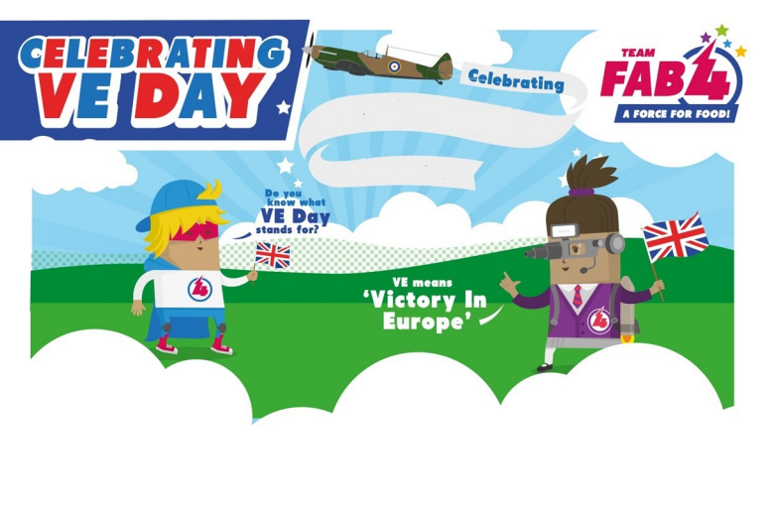
VE DAY MENU
VE Day
Thursday 8th May

Pork Sausage or Veggie Sausage

Served with Mashed Potatoes and Peas or Beans
Or
Jacket Potato with Cheese, Beans or Tuna

Ham Sandwich

Dessert

Treacle Sponge and Custard

