

Norton Free Church of England Primary School
Caring, Confident, Accomplishing


Matthews Lane

Norton
Sheffield
S8 8JS




Headteacher Mrs H Bell
Tel (0114) 2745 873
Fax (0114) 2359 060
E-mail headteacher@nortonfree.sheffield.sch.uk
Website www.nortonfree.org.uk

Dear Parents and Carers,

Cross Country Race 1 – Whirlow Playing Fields, Limb Lane, Dore S17 3ES – Sat 4th October

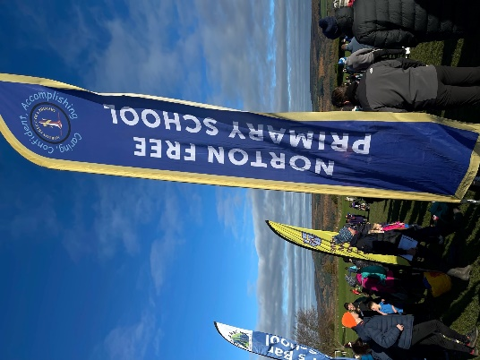
We are about to embark upon another season of Cross Country and the first race of the season is at a new venue – I can confirm that the race will take place at: Whirlow playing fields, Limb Lane, Dore, S17 3ES on Saturday 4th October. I don’t know anything about this venue, but I will be there at 9am with my Cross Country Flag, waiting for my awesome Cross Country team. Children usually arrive between 9:15 – 9:30am, please leave time for parking- it can be tricky.

The Y3/4 girl’s race starts first at 10am. The children usually run a distance from 800m to 1500m. Y5/6 run further than the Y3s and Y4s. After the girls, the Y3/4 boys set off followed by Y5/6 girls and the final race is the Y5/6 Boys race. Children may leave when they have completed their race. I always wait at the finish for the children and they need to let me know their finishing position (they will be given ticket with a number on). I will enter these results in the league. We are very competitive against much larger schools that have loads more children!

To the new Y3 parents, I hope your child will try out Cross Country on 4th Oct and become a part of the team. I have run the Cross Country Team at Norton Free since around 2006 when my own children took part. I am completely hooked and I would love the Y3 children to come along and join the children from Y4 Y5 and Y6 in a morning of racing against other primary schools. It is hard work, but it is very enjoyable and the children really support one another and they try really hard to improve on their positions each week. There is a Cross Country League and I enter our results into the league. The first 4 children to the finish are counted as Team A, the next 4 Team B etc. For a small school, we do really well with the number of children participating and we have some very good runners!

If your child commits to Cross Country, I will provide them with a team t-shirt and I have accumulated a large number of running spikes! I add a race report to the website each week and on our face book page. If your child is interested, just turn up on the Saturday and come to the flag to let me know that you are here so I can look out for the children at the finish. You are able to walk the course before hand as long as this is completed by 9:30am. I usually take the Y3/4 girls to the starting pens for the first race at 10am.

Looking forward to seeing as many of you as possible on Saturday 4th October at Whirlow Playing Fields!
Kind regards,

Hazel Bell
Headteacher
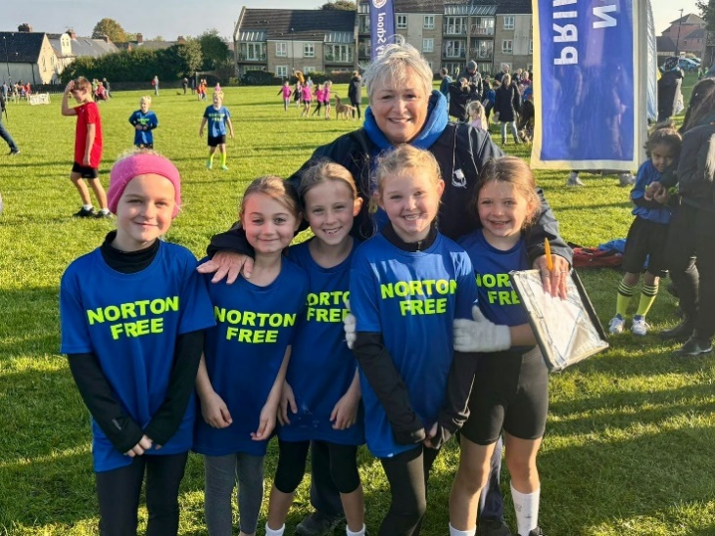

Our Y3/4 Girls last season.

