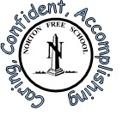

Norton Free C of E Primary school – Handwriting and Presentation Policy
Reviewed April 2026
Aim:
We aim to teach handwriting so that children develop legible, consistent and fluent handwriting, starting in Foundation Stage and continuing in each class, through to Y6. Handwriting is a skill that needs to be taught explicitly. The teaching of handwriting at Norton Free C of E Primary school is based on the Sheffield Structured Handwriting Scheme where every letter sits on the line with clear ascenders and descenders. During the course of their time at this school, explicit handwriting lessons will be timetabled and the children will be introduced to a range of knowledge, skills and understanding. We aim to raise standards in writing across the school by ensuring a clearly structured, taught progression in handwriting and presentation skills. Handwriting is a fine motor movement skill and children need to practise handwriting movements correctly and often. Teaching of handwriting will also be multisensory. Every pupil should have a good view of the adult and what is being modelled in handwriting lessons, including pencil grip. They should have space to write and be seated at the right height.
In teaching handwriting, we aim for our pupils to:
- Understand the importance of clear and neat presentation in order to communicate their meaning clearly
- Be able to write quickly to aid expressing themselves creatively and imaginatively
- Be able to use a cursive handwriting style as they move through the school
- Should be proficient in each stage of handwriting before moving onto the next stage
EYFS
- In Foundation Stage, children will learn how to use a pencil and hold it effectively using a tripod grip to form recognisable letters, most of which are correctly formed.
- Children will learn to print all the letters of the alphabet.
- It is important to ensure that the children learn to form the letters of the alphabet with the
correct sequence of strokes and secure the correct pencil grip.
- Children will be taught to write from left to right and from the top to the bottom of the page.
Key Stage 1
- Children will be taught to sit correctly at a table holding their pencil appropriately
- Children will be taught to write from left to right and from the top to the bottom of the page.
- Children will put regular spaces between letters and words.
- Children will learn how to form Capital letters
- Children will learn how to form digits 0 - 9
- Children will learn about the relative size of the letters (e.g. c and l), using ascenders and descenders
- Children may be taught letter families so they know where letters start e.g c, a, d, g, o, q
- Children will begin to add joining lines (flicks) to letters that sit on the line (a, d, i, k, l, m, n, t, u)
- Children will begin to use a cursive handwriting style in Year 2.
Key Stage 2
- To write legibly in a cursive joined style with increased fluency and speed.
- Children begin by joining digraphs and trigraphs in Y3
- Children join all lowercase letters in Y4
- Children will begin all letters on the line leading in from the bottom and join all the letters except Capital Letters. Children in KS2 will follow the Sheffield Structured Handwriting Scheme.
- All diagrams and tables and all work in maths books must be completed in pencil.
Assessment
The assessment of children’s handwriting and presentation is on-going to ensure that understanding is being achieved and that progress is being made. There is also a statutory expectation to summatively assess handwriting as part of the KS2 Writing Assessment process.
Across the Curriculum
It is important to ensure that appropriate attention to handwriting and presentation takes place in all areas of the Curriculum. For example, during Science, pupils may be labelling a diagram or writing a report and in Art/Design they may be designing packaging where a cursive script would not be appropriate. In this sense other subjects can be used outside the explicit teaching of handwriting to give opportunities for reinforcing key knowledge, skills and understanding with regard to handwriting and presentation. Adult’s handwriting should provide a model of high standards, across the curriculum and not just in handwriting lessons, and particularly when pupils are learning to write.
Letter Formation
Children are taught to form letters correctly, paying attention to the starting points for each letter, the direction pf pencil movement, the shape and orientation of each letter, the relative heights of each letter and ascenders and descenders. Teaching will be multi-sensory. Handwriting will be taught in regular, short handwriting sessions linked to spelling patterns. Handwriting books are provided for handwriting practice and handwriting should also be practised in English Books. It is important that children are encouraged to take pride in their handwriting and presentation.
Inclusion
Most pupils are able to write legibly and fluently. However, some pupils need more support and a specific individual or group programme to support (e.g. Speed UP). This is drawn up in consultation with the SENCo. We may offer thicker triangular pencils, pencil grips and wider lines or coloured paper for children experiencing problems with writing alongside other activities to develop their fine motor skills. All teachers are aware of the specific needs of left-handed pupils and make appropriate provision.

Posture:
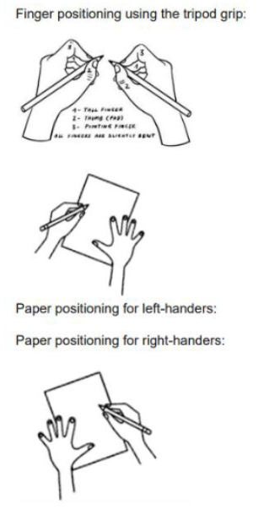
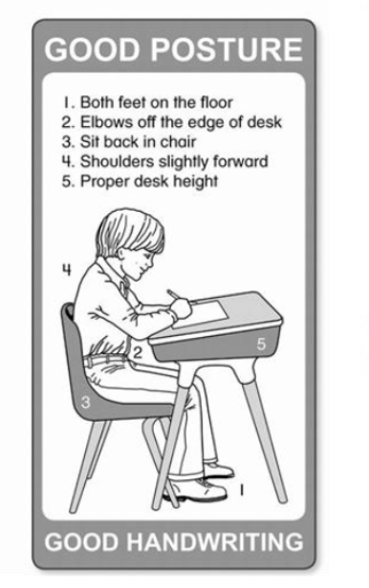
Children should be taught the importance of sitting upright and correctly on their chair, with both feet on the floor. All work in books should be done while sitting at a table, not on the floor. Paper and books should be steadied with their free hand.

Teachers and Teaching Assistants will show pupils what ‘poor’ sitting looks like: leaning forward, close to the paper; resting their head in their hand or on the table; dangling their non-writing arm or hand instead of using it to steady the paper.
Pupils who have an uncomfortable pencil hold or lack the body strength to maintain a comfortable writing position will be distracted by the physical difficulties and unable to concentrate on the content of their writing. Poor postural control can cause difficulties such as pain or fatigue. These then show themselves in pupils’ reluctance to write, poor presentation or legibility, slow writing and reduced output. Adaptive equipment is available for those that struggle with underlying stability, gross and fine motor skills.
Establishing good habits of posture and position early on is helpful; correcting bad habits later is much more difficult.
The book or paper should rest on a flat surface unless children benefit from working on a slant. Pupils need to be taught explicitly how to hold a pencil. An inefficient pencil grip can cause discomfort, which can affect motivation, fluency, legibility and create difficulty in sustaining speed. Staff should also support pupils to apply appropriate pressure as they write, since this is important for fluency and reduces the risk of pain.
Before any handwriting teaching starts, pupils should have pencils sharpened, ready on tables; grip-supports and finger markers in place on pencils, if needed; paper in position; and any necessary adjusted equipment in place. All pupils can be taught to turn their paper: slightly anti-clockwise for right handers and clockwise for left-handers. This particularly helps left-handers to have a good view of what they are writing, since their left hand moves away from what they have written.
Left-handed pupils and adaptations;
When a right-handed person writes in English, the hand is being drawn away from the writing as they write, allowing them to see what they have written. However, the left-handed person’s hand follows behind the writing. About 10% of pupils are left-handed and face some of the following problems:
- Smudging
- obscuring their writing with their writing hand
- difficulty making ‘finger spaces’ between words
Left-handed pupils need specific demonstration and adjustments, including by making sure they:
- have space to write
- sit to the left of any right-handed pupil to prevent their arms colliding
- turn their paper to the right
- use softer pencils that require less pressure
- grip the pencil at a slightly higher point so they can see around their fingers
- do not hold the pencil too tightly or press down too hard
Typical letter families are:
c o a g q d
i l t k j
v w u y f
r n m h p b
e s x z
Pupils should be taught to write each ‘family’ of lower-case letters correctly on the line,
and then to write words that include letters from that family.
Pupils should be taught two basic joins: diagonal joins and horizontal joins.
The diagonal join connects:
- letters from the line to small letters
- letters from the line to tall letters
- letters from the line to a, d, g, c, o, q (These letters need an extra stroke
backwards across the top of a, d, g, c, o.)
The horizontal join connects:
- v, w, x, f, r to small letters
- v, w, x, f, r to tall letters
- v, w, x, f, r to a, d, g, c, o, q

Presentation:
Organisation of Written Work –
It is essential that all children should take pride in their work and set it out well. Children will be reminded to take care of their books and present their work neatly.
Children will write their name, Year group and ‘subject’ on the front cover, in pencil and as neatly as possible. A plain label may be put on the cover if the book is dark in colour. Nothing else should be written on the book cover.
Danny James
Year 4
English

In Key Stage 1 and Key Stage 2, children will begin new work on a new page each lesson unless there is a considerable amount of space left. Teacher’s comments or symbols will indicate whether a correction needs to be addressed. Criteria for the presentation of work will be discussed with the children prior to commencement of work. If the child is absent, the class teacher/TA will write the date and ‘absent’ in their books.
- Each new piece of work will start with the date written next to the margin. The Learning Objective, will be written under the date, next to the margin. Both the date and the LO will be underlined. The date and LO will be written in books by the child or in another form.
- The class teacher or Teaching Assistant may write the LO and date for children who find writing this too time consuming. Alternatively, the date and LO can be printed on a label and stuck in the child’s book.
- Dates are written from Year 1 and underlining is introduced towards the end of Year 1.
- In English and topic books, the long date is written e.g. Monday 1st September. In maths books, the date should be written numerically e.g. 1.9.26
- Rulers are to be used to underline and to draw straight lines. Rulers will always be used when children need to draw lines.
- A line is missed between the LO and starting the written work.
- Mistakes will be crossed out with single ruler lines.
- Pupils in KS1 and lower KS2 will write with pencil.
- Any pictures should be coloured in pencil crayons. Felt pens should not be used in exercise books.
- Pupils in Upper KS2 will write in pen when they receive a pen license.
- One digit per box in Maths books where pencils are always used.

Margins:
Margins are not required in maths books.
In English books, for children who find it difficult to set out their work, teachers may draw a green line on the left-hand side of the page and a red line on the right-hand side. The green line indicates that this is where children start their writing (go) and they stop when they reach the red line.
Correcting mistakes:

The use of rubbers is discouraged except in the case of work for a display. Mistakes made in pencil or pen, should be crossed out using a single line (with a ruler).

Paragraphs:

A line is missed between paragraphs. There is no need for children to indent the first word of the new paragraph.

Plain Paper and line guides:

When children are used to writing on lines in books, they should use a line guide when writing on plain paper and in books with no lines. Line guides should be used with paper clips.

Worksheets:

The use of worksheets is discouraged, children should be encouraged to write for themselves wherever possible. If a worksheet is used, these can be kept separately rather than stuck into books.

Pen Licences:

A pen licence is a non-compulsory recognition of achievement, given at the teacher’s discretion, when they assess the child’s handwriting to be of a certain standard. Factors influencing the decision of when to award a pen licence may include:
- holding the pencil correctly
- writing on a line
- the correct size of letters
- the correction formation of letters
- the correct joining of letters
- legibility
Teachers are likely to assess this over a number of weeks, rather than in a one-off handwriting test.

Monitoring and Evaluation
When undertaking work scrutiny subject leaders will monitor all subjects for neat presentation and
legible, accurately formed handwriting. The English Leader will monitor that handwriting is taught,
practised and modelled throughout the school and that the agreed progression is followed.
This policy will be reviewed annually.
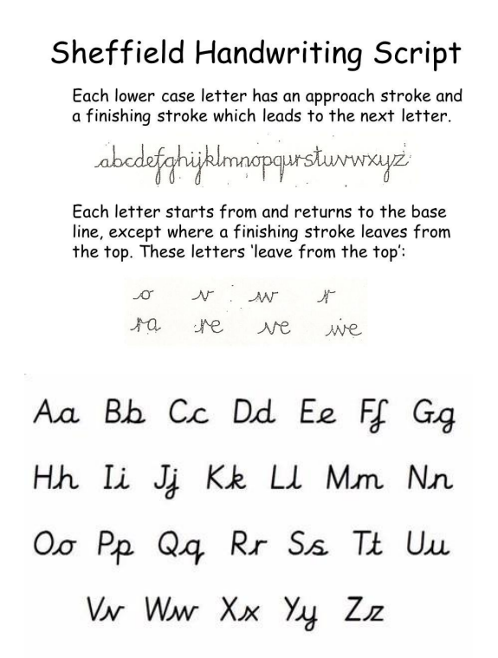

Key Stages 1 and 2 | Statutory  Requirements | Non-Statutory Notes and Guidance
Year 1, Age 5–6 | Pupils should be taught to:  • sit correctly at a table, holding a pencil comfortably and correctly  • begin to form lower-case letters in the correct direction, starting and finishing in the right place  • learn unjoined handwriting before they start using some of the diagonal and horizontal strokes that are needed to join letters  • form capital letters  • form digits 0–9  • understand which letters belong to which handwriting ‘families’ (i.e. letters that are formed in similar ways) and to practise these. | Handwriting requires frequent and discrete, direct teaching. Pupils should be able to form letters correctly and confidently. The size of the writing implement (pencil, pen) should not be too large for a young pupil’s hand. Whatever is being used should allow the pupil to hold it easily and correctly so that bad habits are avoided.  Writing is likely to develop at a slower pace than reading at this stage. This is because pupils need to encode the sounds they hear in words (spelling skills), develop the physical skill needed for handwriting, and learn how to organise their ideas in writing.  Left-handed pupils should receive specific teaching to meet their needs.
Year 2, Age 6–7 | Pupils should be taught to:  • form lower-case letters of the correct size relative to one another  • start using some of the diagonal and horizontal strokes needed to join letters and understand which letters, when adjacent to one another, are best left un-joined  • write capital letters and digits of the correct size, orientation and relationship to one another and to lower case letters  • use spacing between words that reflects the size of the letters. | Pupils should revise and practise correct letter formation frequently. They should be taught to write with a joined style as soon as they can form letters securely with the correct orientation.
Years 3–4,  Age 7–9 | Pupils should be taught to:  • use the diagonal and horizontal strokes that are needed to join letters and understand which letters, when adjacent to one another, are best left un-joined  • increase the legibility, consistency and quality of their handwriting (for example, by ensuring that the downstrokes of letters are parallel and equidistant; that lines of writing are spaced sufficiently so that the ascenders and descenders of letters do not touch). | Pupils should be using joined handwriting throughout their independent writing. Handwriting should continue to be taught, with the aim of increasing the fluency with which pupils are able to write down what they want to say. This, in turn, will support their composition and spelling.
Years 5–6,  Age 10–11 | Pupils should be taught to write legibly, fluently and with increasing speed by:  • choosing which shape of a letter to use when given choices and deciding whether or not to join specific letters  • choosing the writing implement that is best suited for a task. | Pupils should continue to practise handwriting and be encouraged to increase the speed of it, so that problems with forming letters do not get in the way of their writing down what they want to say. They should be clear about what standard of handwriting is appropriate for a particular task, for example, quick notes or a final handwritten version. They should also be taught to use an un-joined style, for example, for labelling a diagram or data, writing an email address, or for algebra; and capital letters, for example, for filling in a form.

