

Norton Free Church of England Primary School
Caring, Confident, Accomplishing



Matthews Lane
Norton
Sheffield
S8 8JS

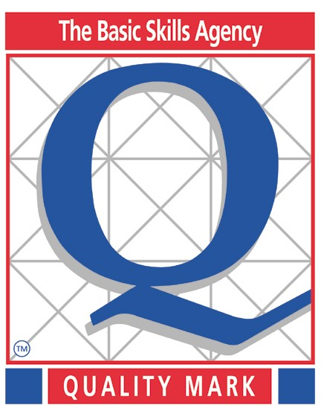


Headteacher Mrs H Bell
Tel (0114) 2745 873
Fax (0114) 2359 060
E-mail headteacher@nortonfree.sheffield.sch.uk
Website www.nortonfree.org.uk

Privacy Notice (How we use pupil information)
The categories of pupil information that we collect, hold and share include:
- Personal information (such as name, unique pupil number and address)
- Characteristics (such as ethnicity, language, nationality, country of birth and free school meal eligibility)
- Attendance information (such as sessions attended, number of absences and absence reasons)
- Assessment data (such as end of year phonics screening, year 3 non-verbal reasoning, KS1 and KS2 SATS)
- Other relevant educational information (such as relevant medical information, special educational needs information and behaviour monitoring)
Why we collect and use this information
We use the pupil data:
- to support pupil learning
- to monitor and report on pupil progress
- to provide appropriate pastoral care
- to assess the quality of our services
- to comply with the law regarding data sharing
- to ensure that the children are safe in our care

The lawful basis on which we use this information
We collect and use pupil information that is necessary to educate and keep the children safe. In addition, it may be required by law to collect and use certain types of information to comply with statutory obligations. As stated in Article 6 and 9 of the GDPR the school will only collect and process pupil information that is relevant and required. In circumstances where consent is required this will be requested in order to hold and process the data (GDPR May 2018).
We will collect data using the following lawful basis:
- It is mandatory information in order to fulfil a task.
- We have a legal obligation to collect the data.
- Where we collect data that is not mandatory we will ask for your consent to process and store this data.

Collecting pupil information
Whilst the majority of pupil information you provide to us is mandatory, some of it is provided to us on a voluntary basis. In order to comply with the General Data Protection Regulation, we will inform you whether you are required to provide certain pupil information to us or if you have a choice in this.
Storing pupil data
We hold pupil data for differing periods of time depending on our legal obligation.
For example, we will keep children’s reports on record for the duration of their time at school and this will then be passed onto their next school when they have left.
Who we share pupil information with
We routinely share pupil information with:
- schools that the pupil’s attend after leaving us
- our local authority
- the Department for Education (DfE)

Why we share pupil information
We do not share information about our pupils with anyone without consent unless the law and our policies allow us to do so.
We share pupils’ data with the Department for Education (DfE) on a statutory basis. This data sharing underpins school funding and educational attainment policy and monitoring.
We are required to share information about our pupils with our local authority (LA) and the Department for Education (DfE) under section 3 of The Education (Information About Individual Pupils) (England) Regulations 2013.
Data collection requirements:
To find out more about the data collection requirements placed on us by the Department for Education (for example; via the school census) go to https://www.gov.uk/education/data-collection-and-censuses- for-schools.
The National Pupil Database (NPD)
The NPD is owned and managed by the Department for Education and contains information about pupils in schools in England. It provides invaluable evidence on educational performance to inform independent research, as well as studies commissioned by the Department. It is held in electronic format for statistical purposes. This information is securely collected from a range of sources including schools, local authorities and awarding bodies.
We are required by law, to provide information about our pupils to the DfE as part of statutory data
collections such as the school census and early years’ census. Some of this information is then stored in the NPD. The law that allows this is the Education (Information About Individual Pupils) (England) Regulations 2013.

To find out more about the NPD, go to https://www.gov.uk/government/publications/national-pupil- database-user-guide-and-supporting-information.
The department may share information about our pupils from the NPD with third parties who promote the education or well-being of children in England by:
- conducting research or analysis
- producing statistics
- providing information, advice or guidance

The Department has robust processes in place to ensure the confidentiality of our data is maintained and there are stringent controls in place regarding access and use of the data. Decisions on whether DfE releases data to third parties are subject to a strict approval process and based on a detailed assessment of:
- who is requesting the data
- the purpose for which it is required
- the level and sensitivity of data requested: and
- the arrangements in place to store and handle the data

To be granted access to pupil information, organisations must comply with strict terms and conditions covering the confidentiality and handling of the data, security arrangements and retention and use of the data.
For more information about the department’s data sharing process, please visit: https://www.gov.uk/data- protection-how-we-collect-and-share-research-data
For information about which organisations the department has provided pupil information, (and for which project), please visit the following website: https://www.gov.uk/government/publications/national-pupil- database-requests-received
To contact DfE: https://www.gov.uk/contact-dfe

Requesting access to your personal data
Under data protection legislation, parents and pupils have the right to request access to information about them that we hold. To make a request for your personal information, or be given access to your child’s educational record, contact Mr Neilson (Data protection officer) or Mrs Gill in the school office.

You also have the right to:
- object to processing of personal data that is likely to cause, or is causing, damage or distress
- prevent processing for the purpose of direct marketing
- object to decisions being taken by automated means
- in certain circumstances, have inaccurate personal data rectified, blocked, erased or destroyed; and
- claim compensation for damages caused by a breach of the Data Protection regulations

If you have a concern about the way we are collecting or using your personal data, we request that you raise your concern with us in the first instance. Alternatively, you can contact the Information
Commissioner’s Office at https://ico.org.uk/concerns/
Contact
If you would like to discuss anything in this privacy notice, please contact: Norton Free C of E Primary
Enquiries@nortonfree.sheffield.sch.uk Mr R Neilson (Data Protection Officer)

