Writing at Norton Free CofE Primary School

We teach our children to be independent, confident writers who enjoy writing. Children are motivated to write because we begin each unit with a hook. All of our writing uses engaging books so that children are exposed to good writing models. We work in 2-week units and the final piece of writing incorporates the skills and knowledge we have acquired over the 2-week unit. Our skills and knowledge progression is carefully planned to ensure that we build on prior learning and that children acquire new skills year on year.

Children in the younger years focus on transcriptional skills such as handwriting, spelling and basic punctuation so that they can use these skills automatically as they write more creatively and independently.

Children in Foundation Stage, Year One, Year Two and Year Three also complete a Talk for Writing unit during the year.

Below you will find the books that we use each term to support the children’s writing.

Year One
Autumn Term | Cave Baby  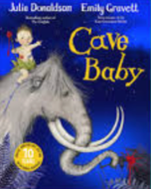 | Avocado Baby  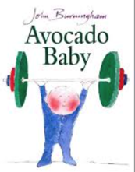 | Beegu  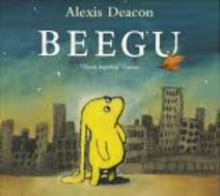 | Astro Girl  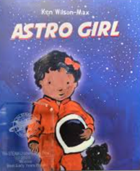 | Leaf  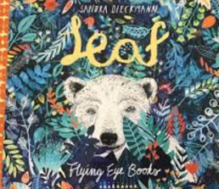 | The Last Wolf  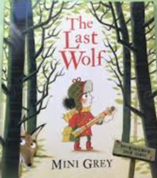
Final piece of writing | Informal letter | List Poem | Account of a crash | Fact file | Fiction | Informal letter

Spring Term: | If all the world were  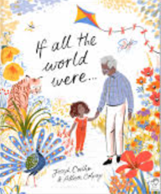 | When  Can you see a little bear?  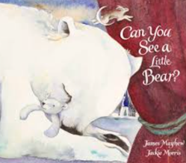 | Rabbit and Bear: Rabbit’s bad habits  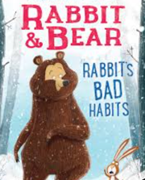 | Seasons  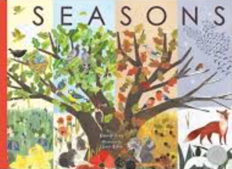 | Dave and the Tooth Fairy  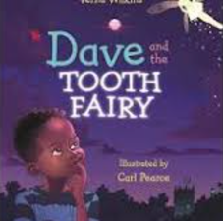 | Robot and the Bluebird  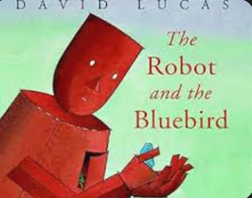
Final piece of writing | Description | Fiction | Description  Informal letter | Fact file | Diary entry | Fiction

Summer Term | Stone Girl, Bone Girl  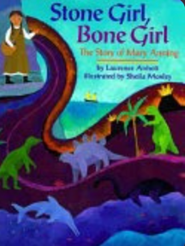 | The Little Green Dinosaur  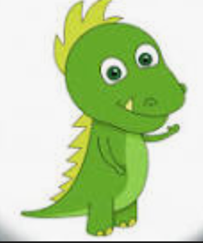 | Rapunzel  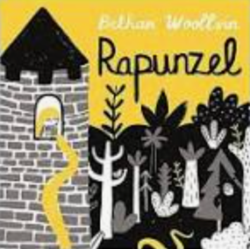 | The Puffin Book of Fantastic First Poems  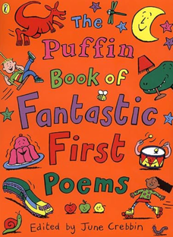 | Claude  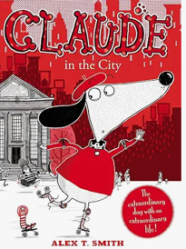
Final piece of writing | Fiction | Talk 4 Writing – fiction | Fiction | Poems | Description  Fiction

Year Two
Autumn | Vlad and the Great Fire of London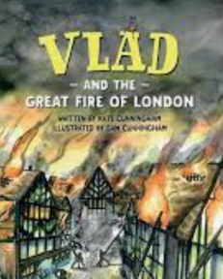 | The Great Fire of London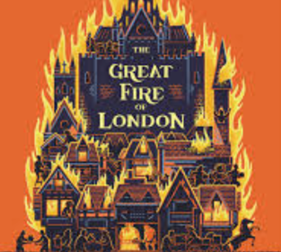 | Toby and the Great Fire of London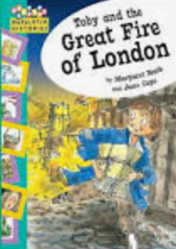 | Goldilocks and the Three Bears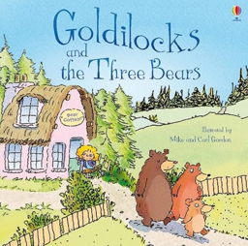 | Jim and the Beanstalk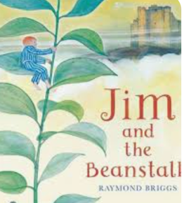 | Mog’s Christmas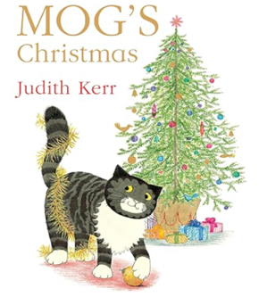
Final piece of writing | Character description | Diary entry | Formal letter | Informal letter | Description | Fiction

Spring | The journey home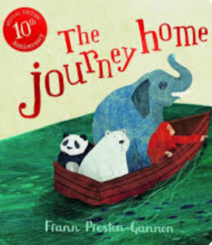 | The Great Kapok Tree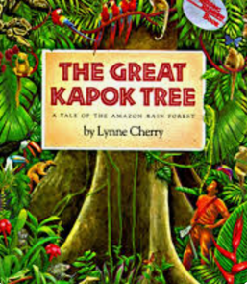 | There’s a Rang Tan in my Bedroom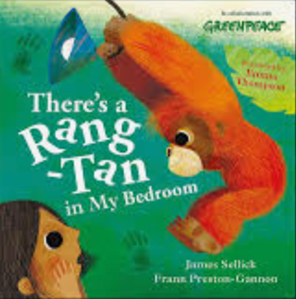 | Traction Man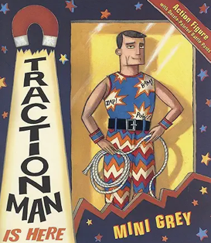 | Vlad and the Florence Nightingale Adventure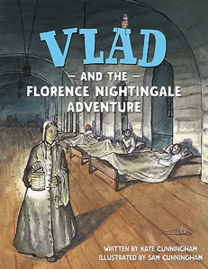 | Little people, big dreams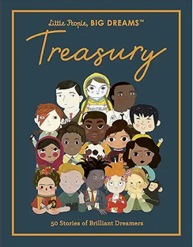
Final piece of writing | Fact file | Poems | Persuasive letter | Description | Diary entry

Summer | Zog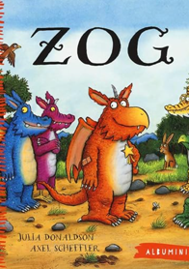 | The Knight and the Dragon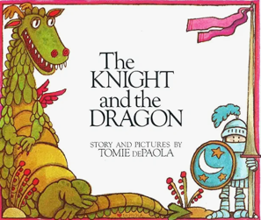 | George and the Dragon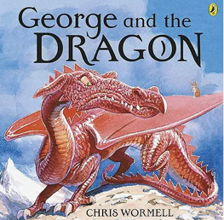 | Lighthouse Keeper’s Lunch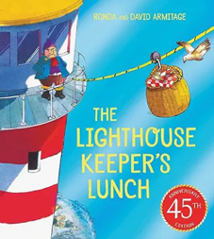 | Once upon a raindrop  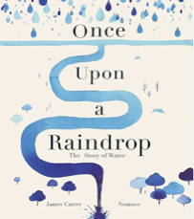
Final piece of writing | Instructions | Fiction | Description | Talk 4 writing  Fiction | Poetry
Year Three
Autumn | Oliver and the Seawigs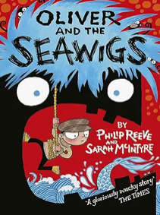 | Oliver and the Seawigs | Flotsam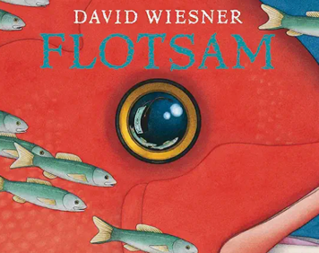 | The Pebble in my Pocket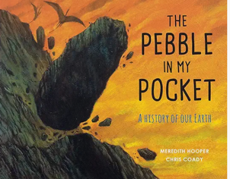 | Mary Anning, Little People, Big Dreams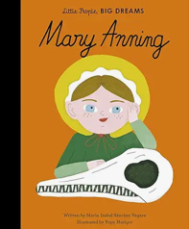 | The Night Before Christmas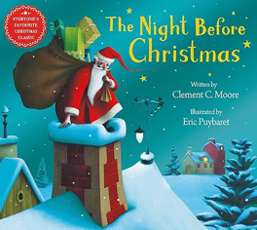
Final piece of writing | Description | Non-chronological report  Fact file | Fiction | Blog entry (informative) | Diary | Informal letter

Spring | Fantastic Mr Fox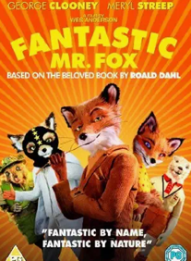 | How far underground? | Travel brochures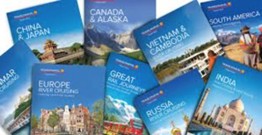 | The Egyptian Cinderella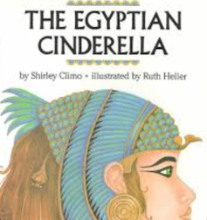 | Daily Life in Ancient Egypt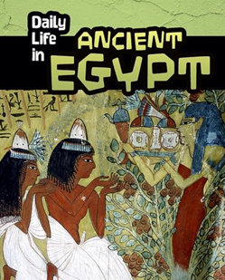 | Marcy and the Riddle of the Sphinx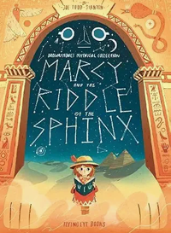
Final piece of writing | Description | Non-chronological report | Persuasive brochure | Fiction | Non-chronological report | Fiction

Summer | Erik the Viking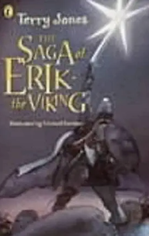 | Who were the Vikings?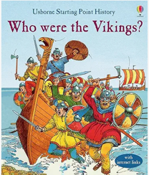 | Viking Sagas 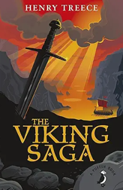 | Pugs of the Frozen North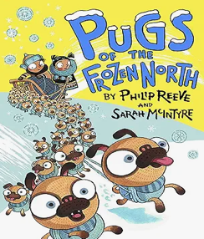 | What was the Ice Age? 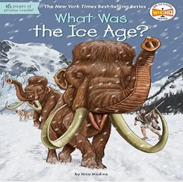 | The Day the Crayons Quit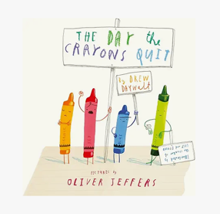
Final piece of writing | Fiction | Information text | Talk 4 Writing  Fiction | Description | Information for a webpage | Formal letter
Year 4
Autumn | Escape from Pompeii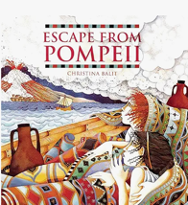 | Mermaid of Zennor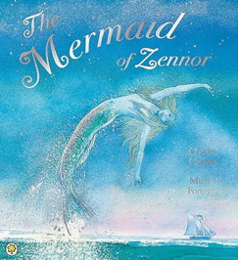 | Farther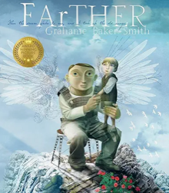 | Vita and the Gladiator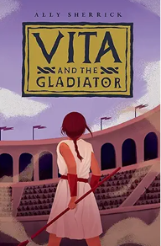 | The Tin Forest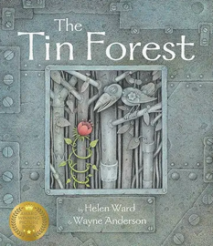 | The Selfish Giant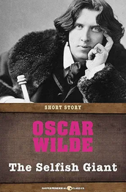
Final piece of writing | Informal letter | Diary | Explanation | Instructions | Fiction | Diary entry

Spring | Penguins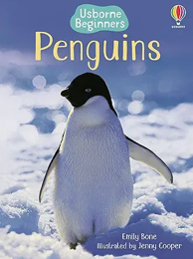 | Einstein the Penguin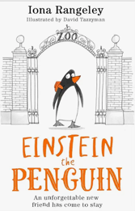 | Winter’s Child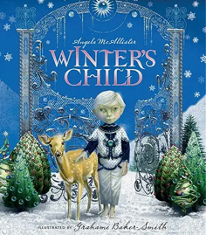 | Shackleton’s Journey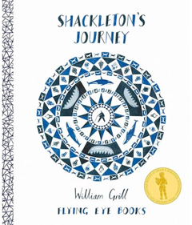 | Miraculous Journey of Edward Tulane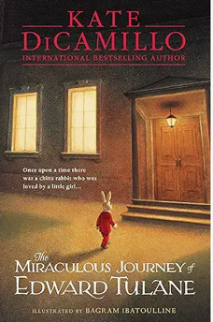 | The Tunnel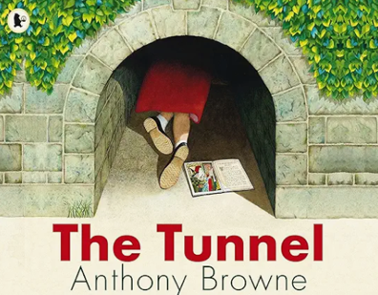l
Final piece of writing | Non-chronological report | Fiction | Description | Persuasive letter | Diary entry | Informal letter

Summer | The Titanic Detective Agency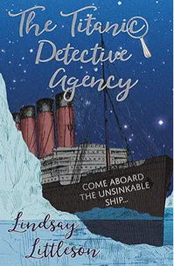 | Treasure Island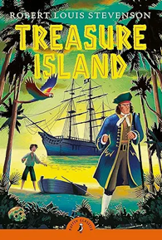 | The Baker by the sea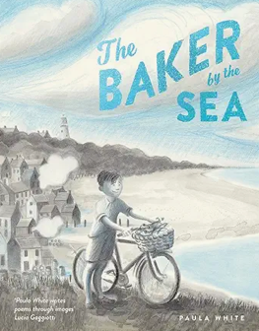 | Orchard Book of Greek Myths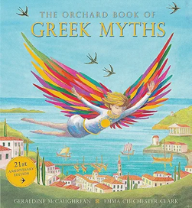 | Beowolf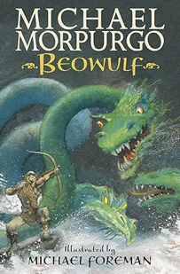 | Beowolf
Final piece of writing | Non-chronological report | Fiction | Description | Description | Description | Fiction
Year 5
Autumn | Hidden figures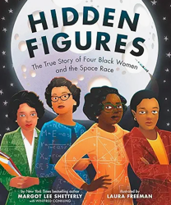 | Can you get Rainbows in Space?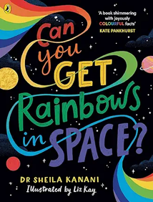 | Lunar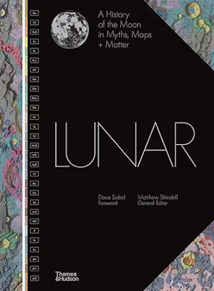 | The man who walked between the Towers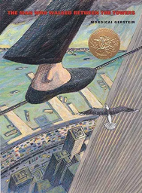 | Black powder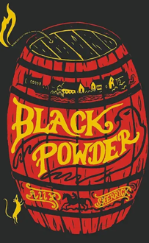 | Holes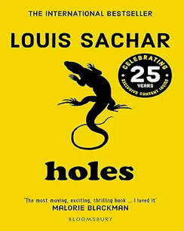
Final piece of writing | Diary | Explanation | Fiction | Persuasive speech | Persuasive letter | Description

Spring | Tom’s Midnight Garden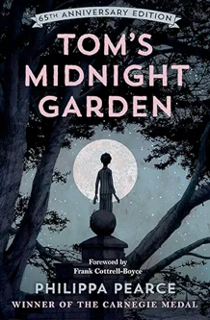 | Street child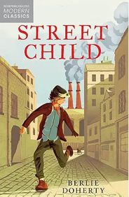 | Pandas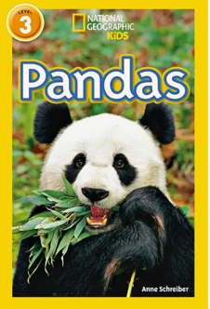 | Kensuke’s Kingdom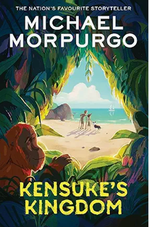 | Kintaro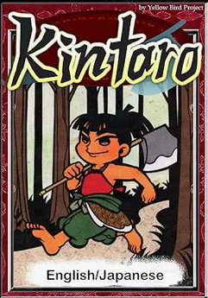
Final piece of writing | description | Diary | Non-chronological report |  | Talk for Writing  Description

Summer | Greek Myths – Persephone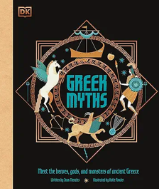 | Odyssey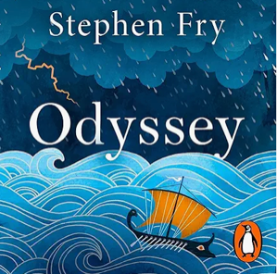 | Who let the Gods out?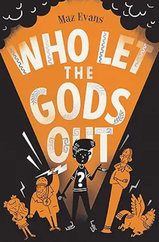 | Tempest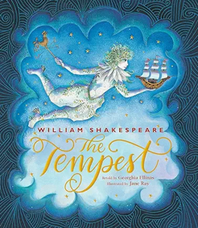 | Breakfast Club adventures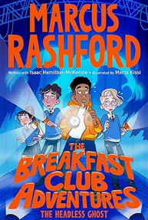 | Stone Age Boy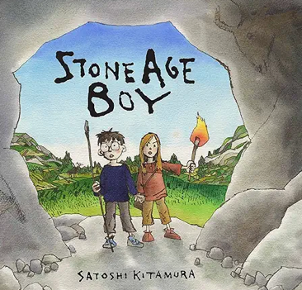
Final piece of writing | Non-chronological report | Informal letter | Narrative | Narrative | Narrative | Narrative
Year 6
Autumn | Goodnight Mr Tom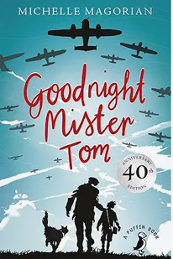 | The Arrival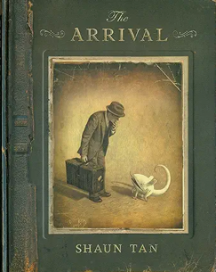 | When Hitler stole Pink Rabbit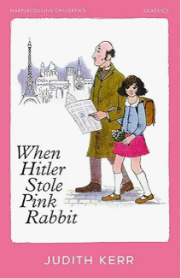 | A Series of Unfortunate Events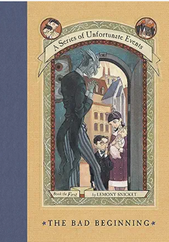 | The Island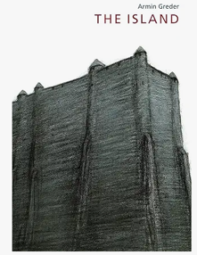 | Our Tower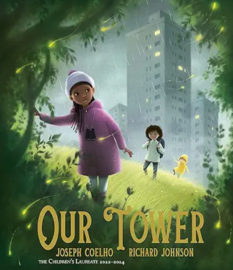
Final piece of writing | Diary entry | Narrative | Informal letter | Description | Persuasive letter | Fiction

Spring | The Ice Bear 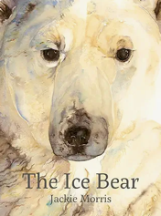 | Northern Lights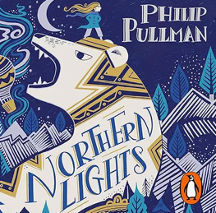 | Arctic Star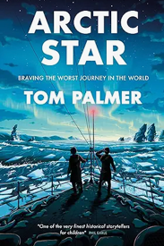 | Journey to the Sea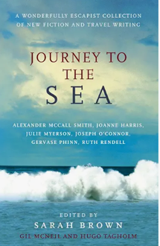 | Go! Go! Chichico!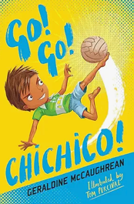 | Ada’s Violin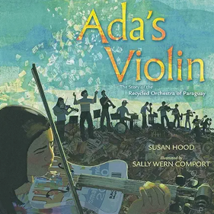
Final piece of writing | Account | Fiction | Non-chronological report | Diary | Narrative | Formal letter

Summer | Middle World 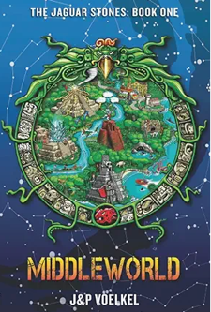 | Oh Maya Gods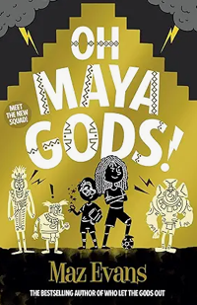 | The Chocolate Tree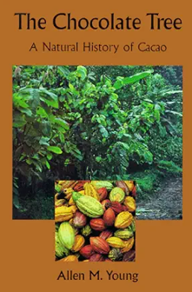 | The Barnabus Project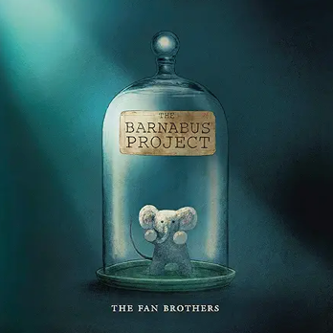 | The Final Year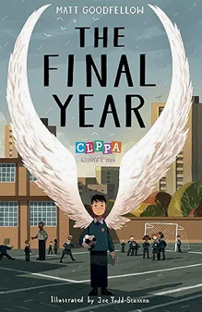 | Wonder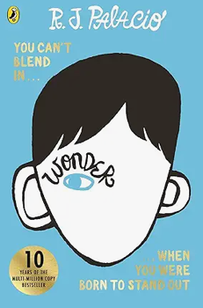
Final piece of writing | Description | Non-chronological report | Explanation | Fiction | Poem | Inner monologue

